**SALE**

* **TO START,  
  1.) Login**

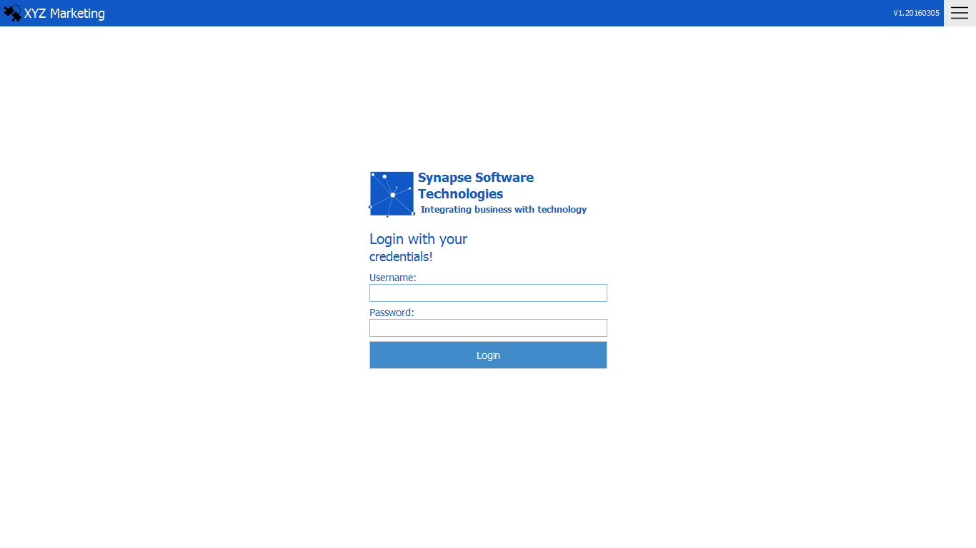**2.) Menu  
3.) Sales**

Log in with the account given

Menu

1 1*1*

Transactions

2 1*1*

Sales

3 1*1*

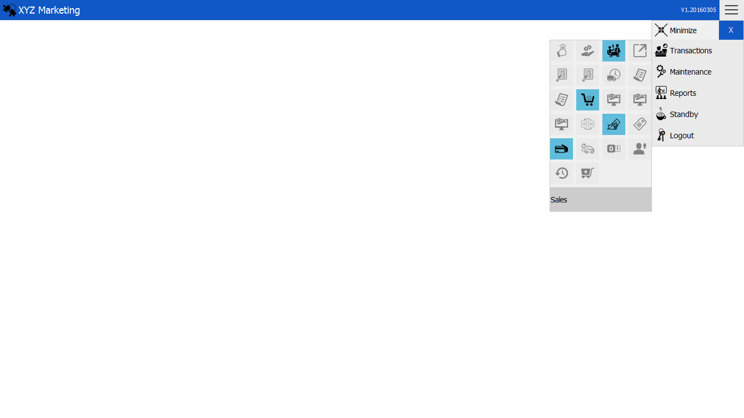

*1*

*1*

* **NEW SALE**

**1.) Search item   
2.) Select item  
3.) Input Customer’s Name  
4.) Pay**

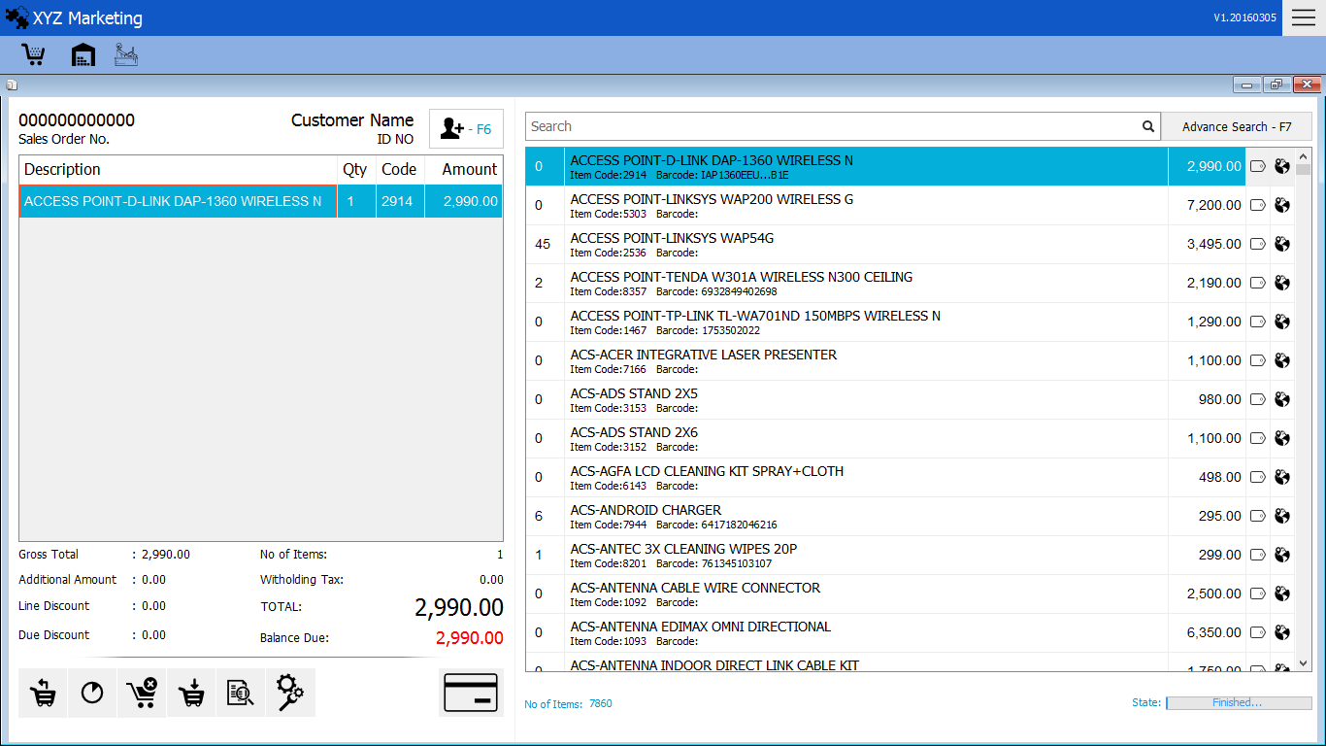

Select Item

Search Item

Input Customer’s Name

2 1*1*

1 1*1*

*1*

*1*

*1*

By Default choose "Receipt from Purchase W/O"

Payment

4

View Orders

View Orders

Discount Order

Save Order

Cancel Order

Remove Item

3

1. 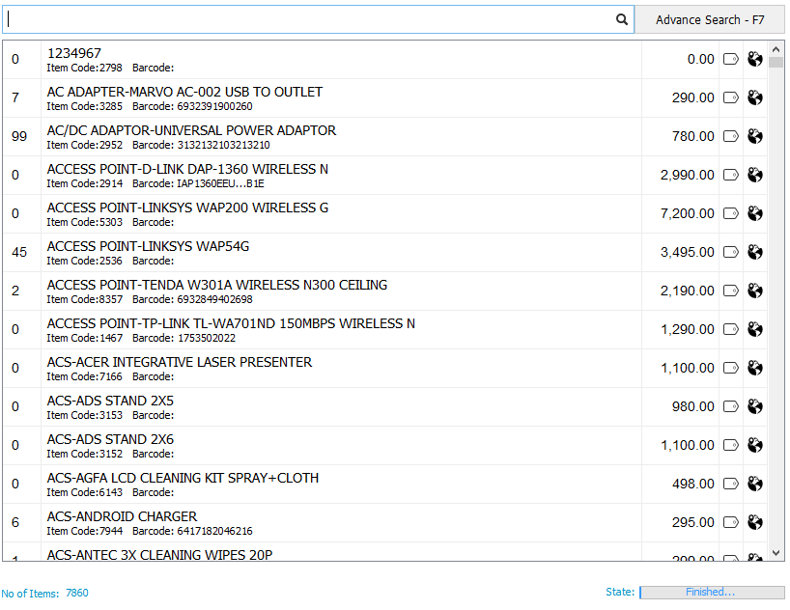**Search an item**

Selling Price

Description

Item code

Number of stocks

We can search item by using the.  
 a.) Item Code   
 b.) Barcode (Input/Barcode scanner)   
 c.) Description

**2.) Select item**

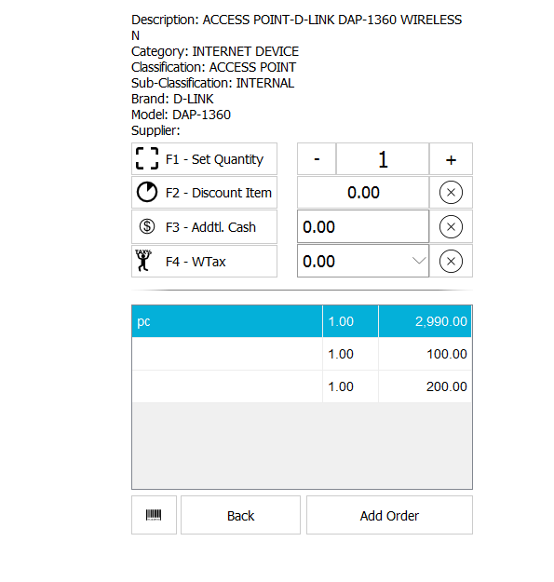

Click the Add Order button to add the item in the list of order

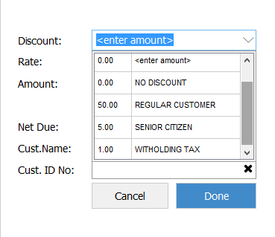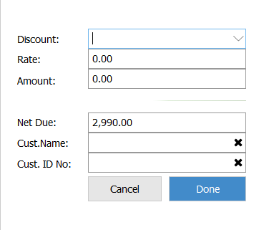**3.) Discount Order**

Enter the amount discounted or choosing with category displayed in the input box

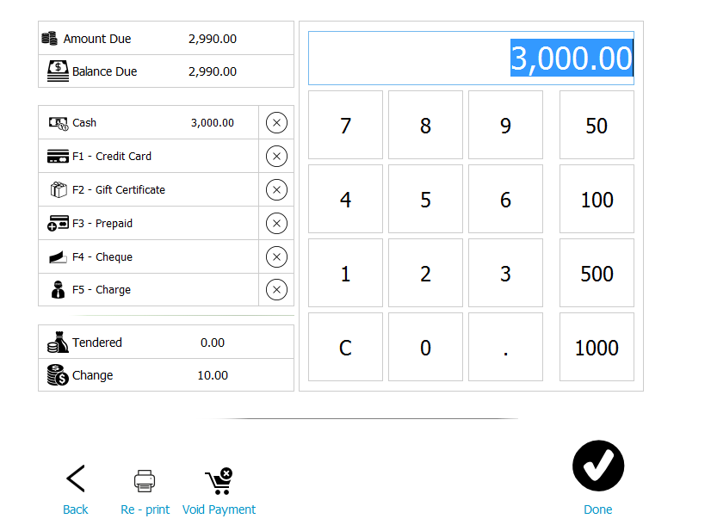**4.) Pay**

Input Cash

List of payments method

Customer’s can pay in different methods with the list given.

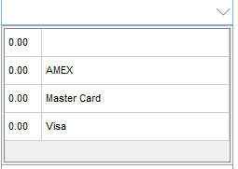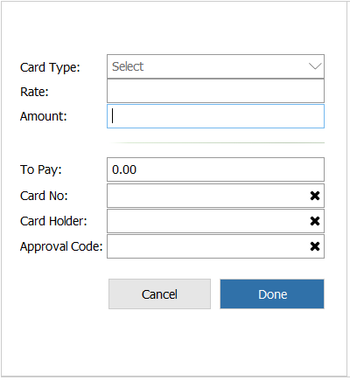**4.1) Credit Card**

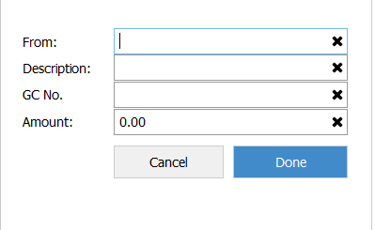**4.2) Gift Certificate**

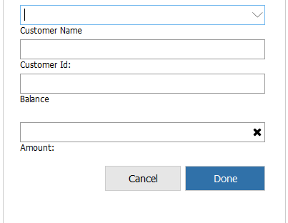**4.3) Prepaid**

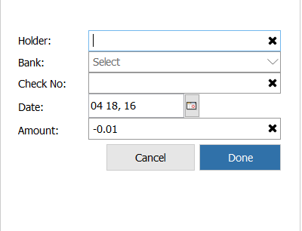**4.4) Cheque**

**4.5) Charge**

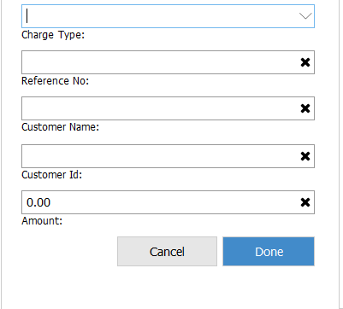

After filling all the payment details. Click done button in the right bottom cornerThe sales details will be shown after pressing the button.

.

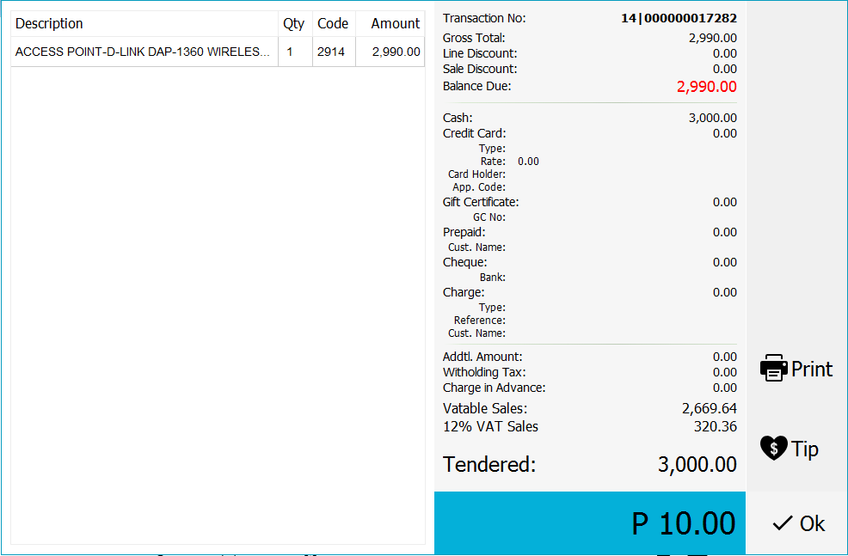

**A.) Input Customer’s Name**

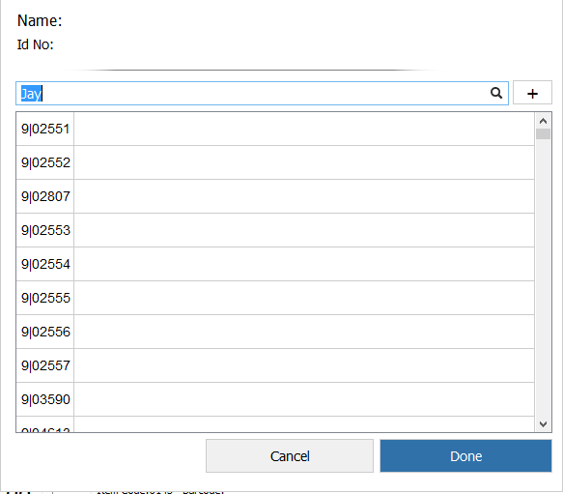

Input customer’s Name if the customer is requesting a receipt with the customer’s name

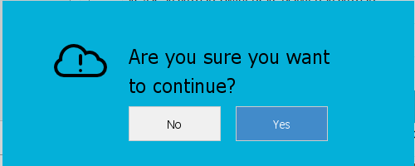**B.) Remove Item & Cancel Order**

This message will appear once the Remove Item and Cancel Order button is clicked.

**C.) Save Order**

This message will appear once the Save Order is clicked.

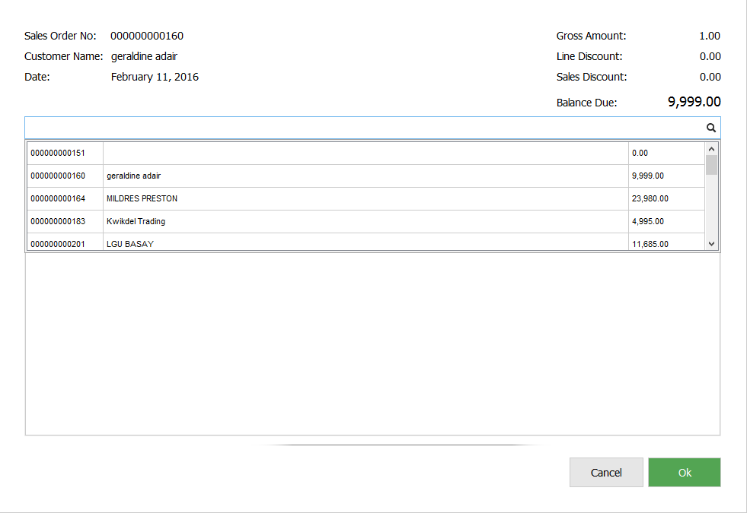**D.) Save Order**

Saved Orders are listed here and choose in the list to continue transaction.

**Cash Reports**

Search Filters

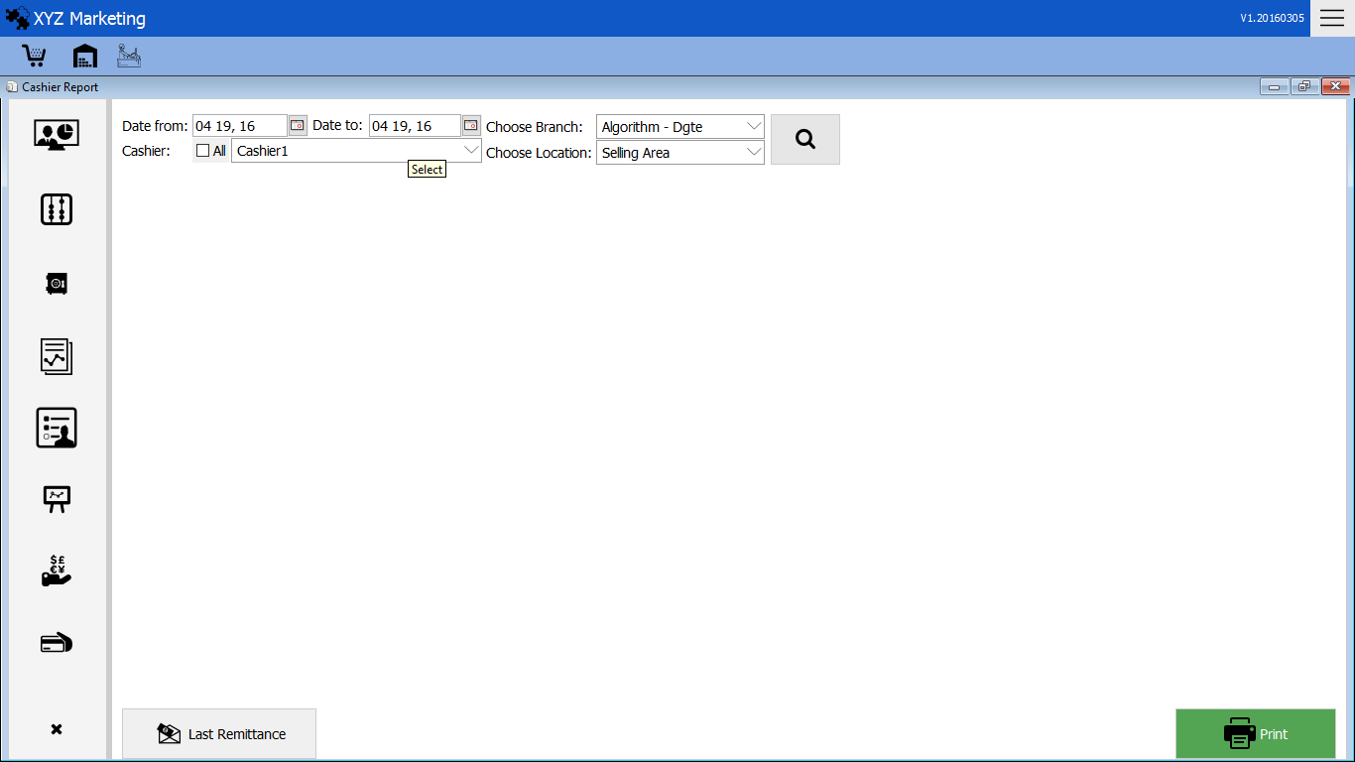

Sales Summary

Void Item

Void Item

Void Item

Sales by Item

Sales Transactions

Remittances

Cash Count

1. **Cash Reports**
2. Search Filter  
    Date – Choose date intervals   
    Branch - Choose branches would like to search   
    Cashier – search the name or which cashier would like to search  
    Location – Choose the location of the branch  
   After filling the search filter click the button to show the sales summary

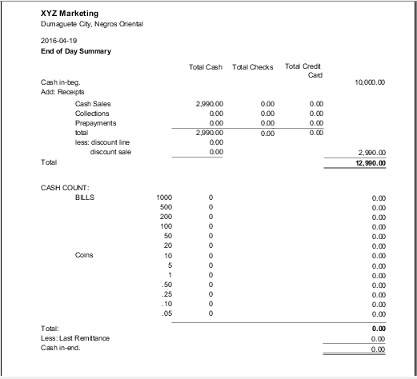

The sales summary will display after clicking the search button

1. **Cash Counts**

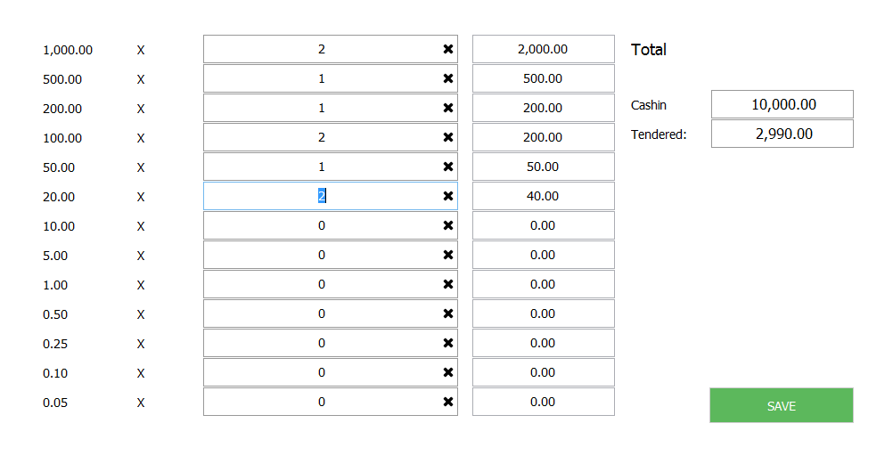

Cash will be counted here and after saving the cash it will be counted in the Cash report

1. 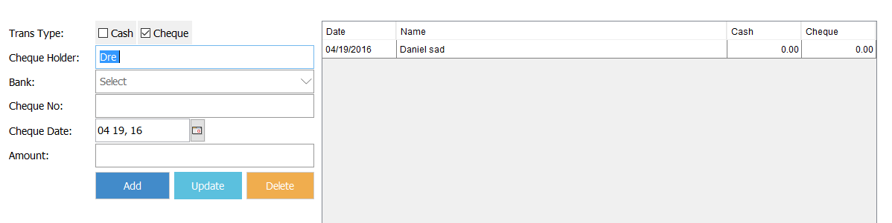**Remittance**

The List of Remittances will be displayed and can also update and add by filling the details.

1. **Sales Transaction**
2. Search Filter  
    Date – Choose date intervals   
    Branch - Choose branches would like to search   
    Cashier – search the name or which cashier would like to search  
    Location – Choose the location of the branch  
   After filling the search filter click the button to show the sales transaction of the cashier

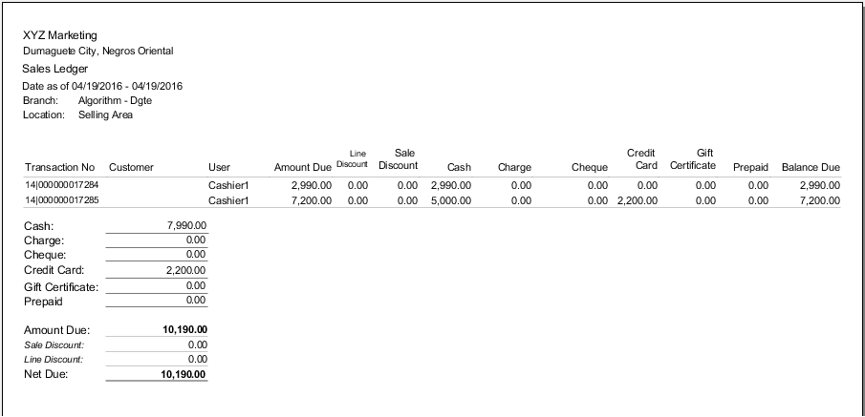

1. **Sales Transaction**

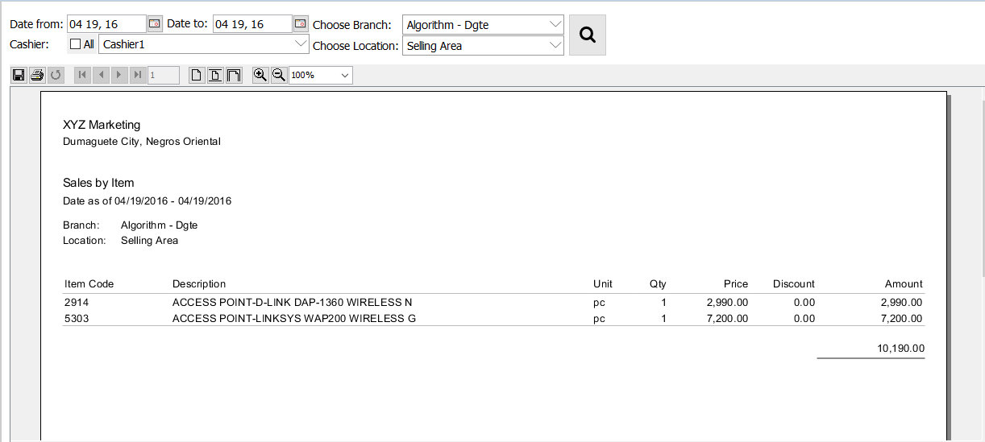

The sales transaction of the cashier will display after filling the details and clicking the search button.

1. 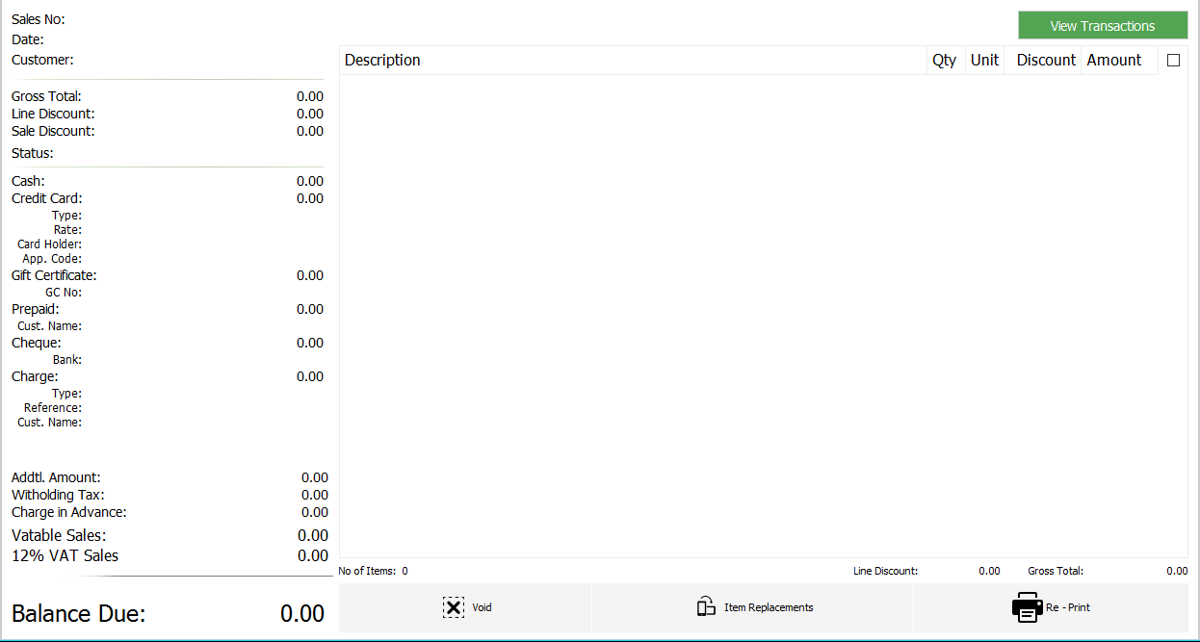**Void/Item replacement/Print**

1 1*1*

To do Buttons

Search/View Transactions

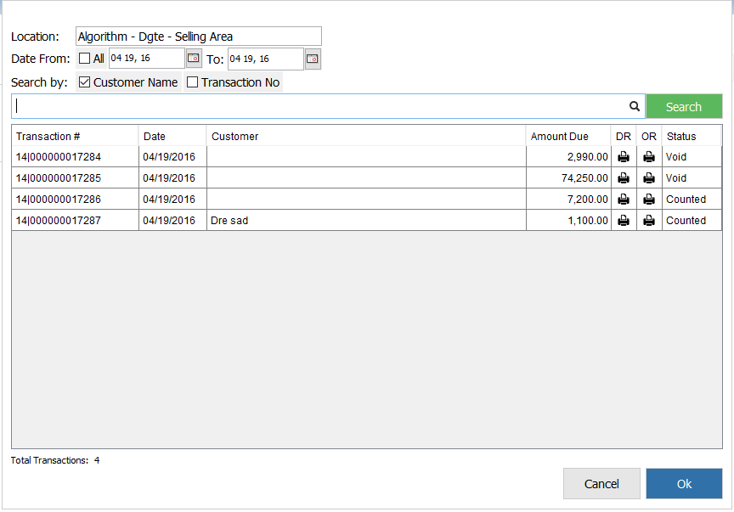

Search Filter

List of Transaction

Print Receipt

Transaction Status

We can search by Customer’s name or transaction number.  
The list of transaction will be displayed after clicking the search button.  
Choose transaction to be updated

* 1. **Void**

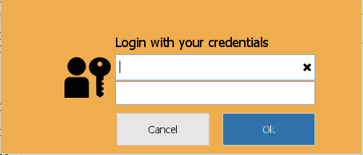Note: Privileged user only can able to void item and the transaction must not more than 1 day ago or the item cannot be voided.

Log in with the privileged user to continue voiding.

Click the button void for voiding the item.

Click the button void for voiding the item.

* 1. **Item Replacement**

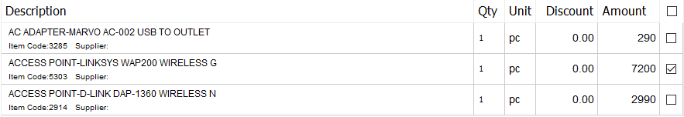

Choose item to be replace by checking the check box in the right side of the item list

Check box



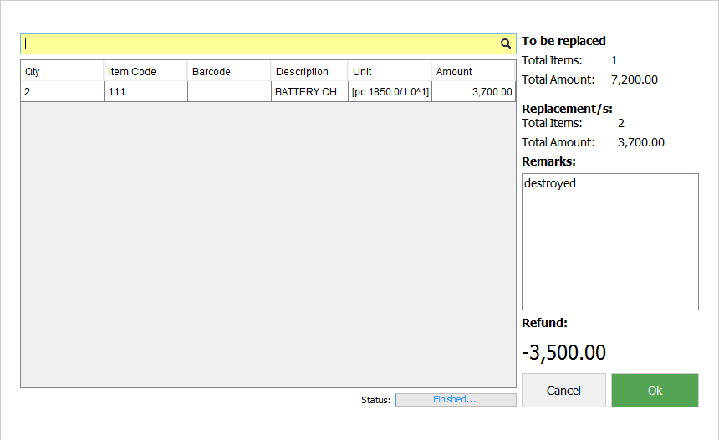

Search Box

Item

Reasons why to replace

Click the button ok after filling all details to continue.

* 1. **Re-print**

Reprint for any changes of the transactions and items.  
Click button to continue.

